PBL 15 Modular Programming - Procedures

1. Write a procedure that computes and displays the square root of a formal parameter - x, if x is greater than zero.  
  
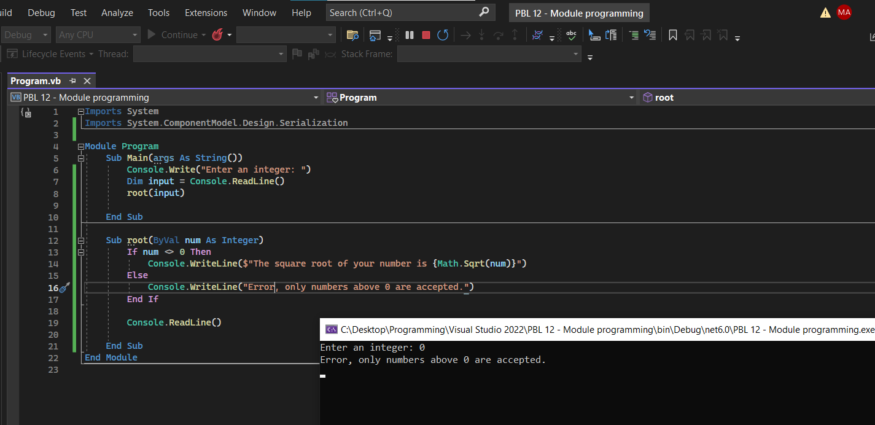

2. Write a procedure that accepts two real values as input and output the sum and difference of the two values.

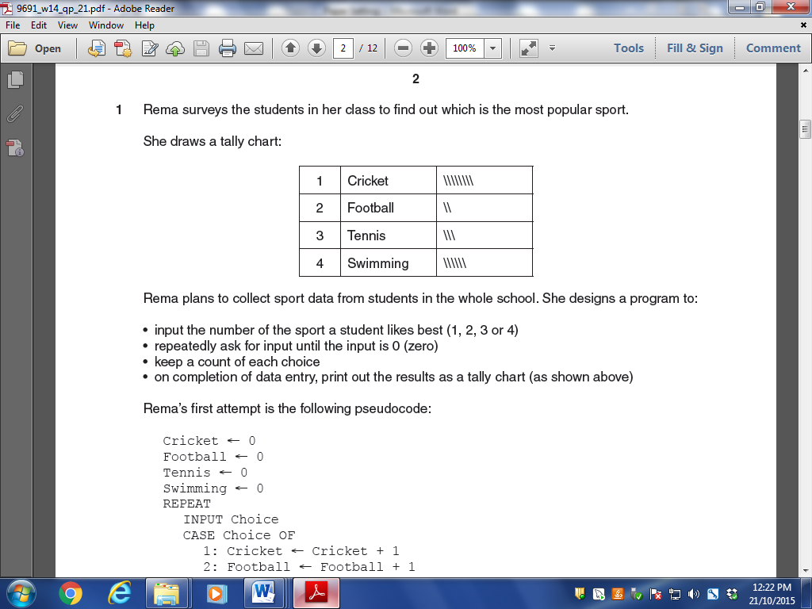

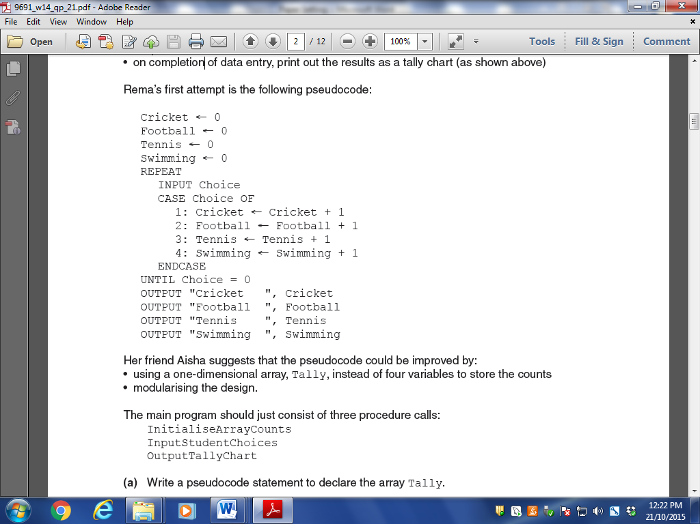3

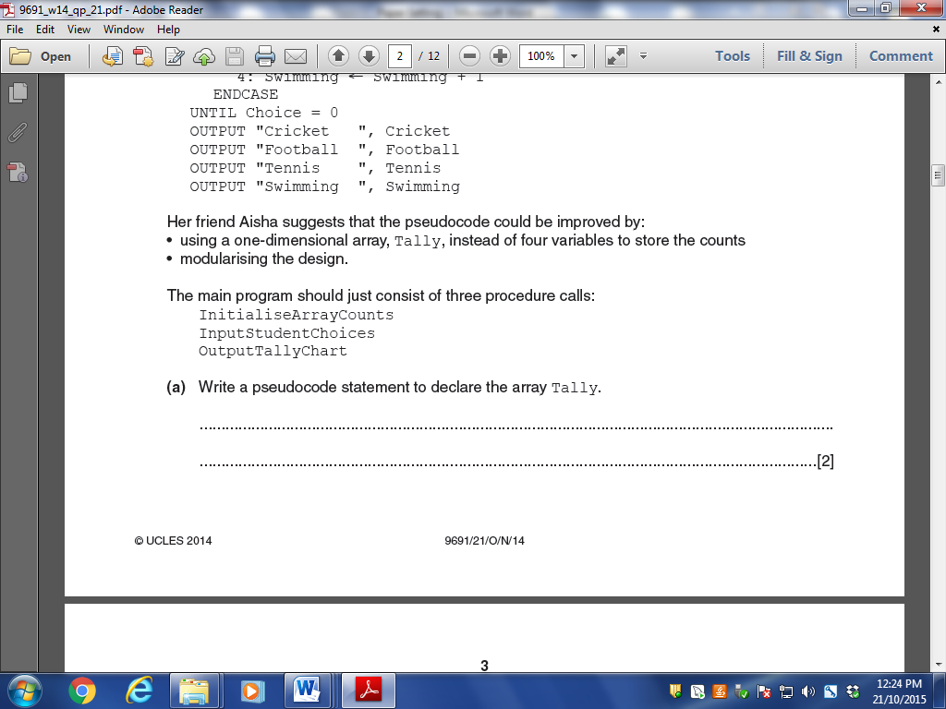

1. Tally[,] Of Integer

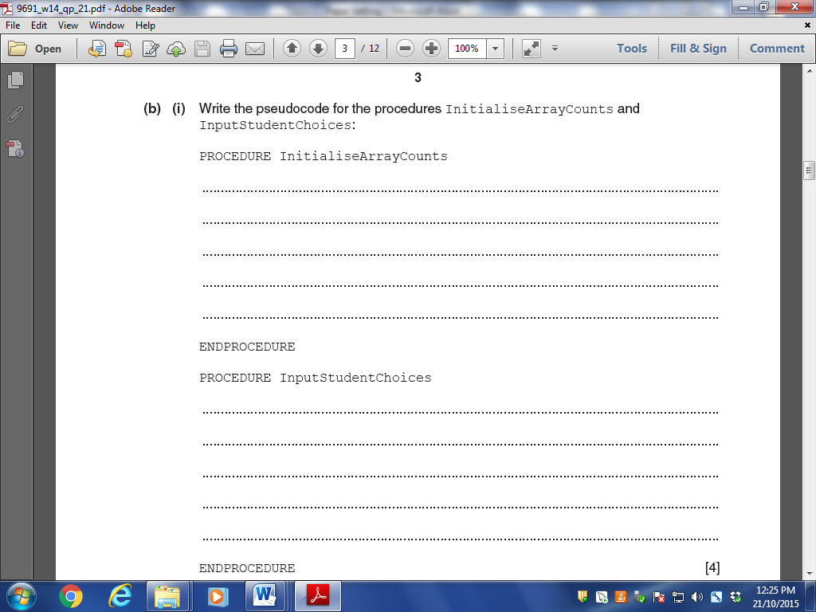

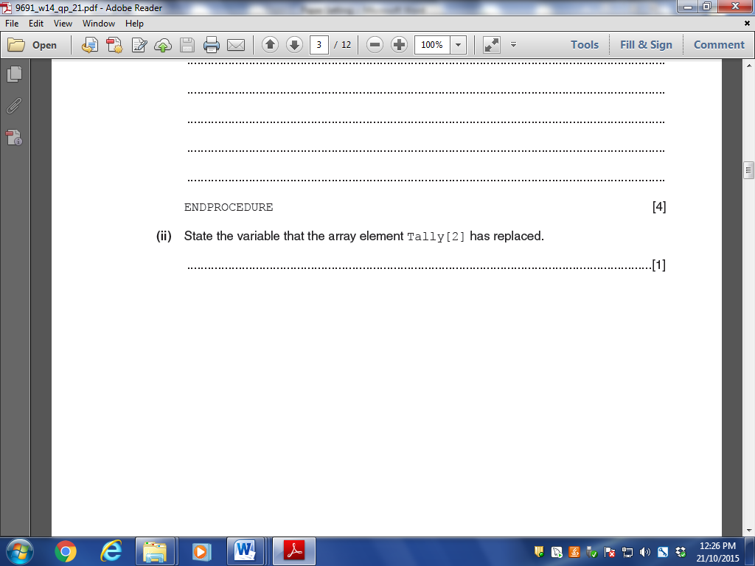

Write program code for all the pseudocode above.

